1952 Montreal Alouettes Line-ups
August 27
From Ottawa Citizen
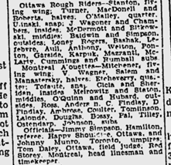
Same game, but from Montreal Gazette
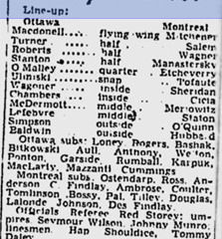
September 6
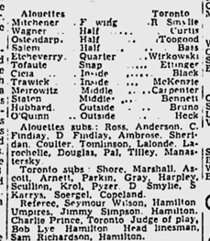
September 13 vs Hamilton
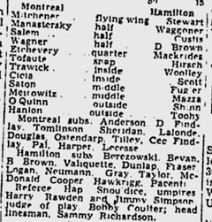
September 20 – Ottawa
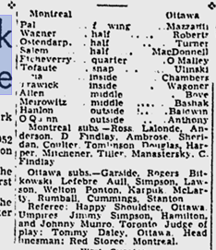
Septemer 28 – Toronto
Paper / Roster missing in Google archives.

October 5 – Hamilton
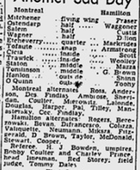
October 11 / October 12 – Ottawa Double header
Only one line-up given – same for both games?
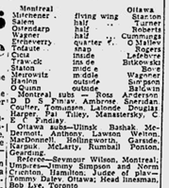
October 18 – Hamilton
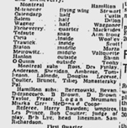
October 26 – Hamilton
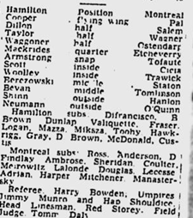
November 2 – Toronto
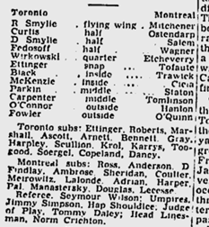

November 8 – Toronto
